Roll No. : 41310
Name : Prem Vinod Bansod
Assignment No : 7 (SCOA)

Problem Statement :
The figure shows a single hidden layer neural network. The weights are initialized to 1‟s as shown in the diagram and all biases are initialized to 0‟s. Assume all the neurons have linear activation functions. The neural network is to be trained with stochastic (online) gradient descent. The first training example is [x1=1, x2=0] and the desired output is 1. Design the back-propagation algorithm to find the updated value for W11 after backpropagation. Choose the value that is the closest to the options given below:[learning rate =0.1]

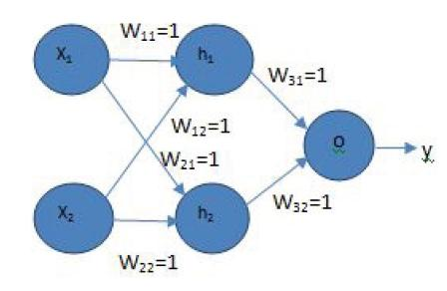

Objective :
- To learn single layer perceptron.
- To learn Boolean logic implementation using perceptron.

Software and Hardware Requirement :
- 32/64 bit PC
- Ubuntu OS
- Python

Theory :
The perceptron is a single processing unit of any neural network. Frank Rosenblatt first proposed in 1958 is a simple neuron which is used to classify its input into one or two categories. Perceptron is a linear classifier, and is used in supervised learning. It helps to organize the given

input data. A 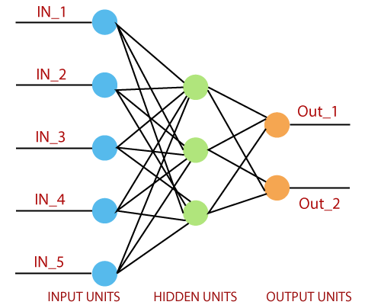
perceptron is a neural network unit that does a precise computation to detect features in the input data. Perceptron is mainly used to classify the data into two parts. Therefore, it is also known as Linear Binary Classifier.
The single-layer perceptron was the first neural network model, proposed in 1958 by Frank Rosenbluth. It is one of the earliest models for learning. Our goal is to find a linear decision function measured by the weight vector w and the bias parameter b.
To understand the perceptron layer, it is necessary to comprehend artificial neural networks (ANNs).
The artificial neural network (ANN) is an information processing system, whose mechanism isinspired by the functionality of biological neural circuits. An artificial neural network consists of several processing units that are interconnected.
This is the first proposal when the neural model is built. The content of the neuron's local memory contains a vector of weight.
The single vector perceptron is calculated by calculating the sum of the input vector multiplied by the corresponding element of the vector, with each increasing the amount of the corresponding component of the vector by weight. The value that is displayed in the output is the input of an activation function.
Let us focus on the implementation of a single-layer perceptron for an image classification problem using TensorFlow. The best example of drawing a single-layer perceptron is through the representation of "logistic regression."
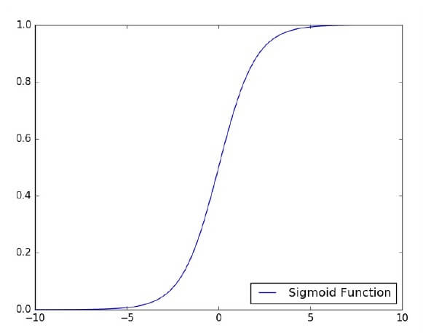

Conclusion :
Hence, The back-propagation algorithm is successfully implemented.

